Bash is a scripting language. It has its own interpreter. All bash script files have .sh extension
- First line in any bash script is The Shebang Line
#!/bin/bash
/bin/bash is the absolute path to the bash interpreter program
- You can use echo to print anything
- # to create comments
- $0 name of the bash script
- Command line arguments can be passed and accessed with $1,$2,…,$9
- No. of arguments passed to the bash script: $#
- All the arguments passed to the bash script: $@
- Exit Code=0 means successful run. Exit Code!=0 means failed. $? Gives exit code of the last command that was run
- $USER: Gives username of the user running the script
- $HOSTNAME: Gives hostname of the machine
- $SECONDS: The number of seconds since the script was started
- In double quotes, variables can be used but not in single quotes
- To print special character, use backward slash (\)
- Command Substitution
Store output of a command in a variable. Done by using `` and $()
Program below
- Export is used to set environment variable in OS. This variable will be available to all child processes created by current Bash process ever after. You can export variables by doing - export VarName=value
- To export variables permanently for a user, add this statement in .bashrc file located in home dir of root user
- To export variables permanently across all users, add this statement in /etc/profile
Note: .bashrc is sourced after /etc/profile is sourced
- User Input: read var1
read -p ‘Username: ‘ USR
read -sp ‘Password: ‘ pass
Bash Script to setup website on CentOs using httpd package
sudo yum install wget unzip httpd -y > /dev/null
echo
echo "Packages installed. Starting httpd service and enabling it"
sudo systemctl start httpd
sudo systemctl enable httpd
echo
echo "Creating temp directory and getting archive"
mkdir -p /tmp/webfiles
cd /tmp/webfiles

wget https://www.tooplate.com/zip-templates/2150_living_parallax.zip > /dev/null
echo
echo "Downloaded archive using wget. Now unzipping the archive"
unzip 2150_living_parallax.zip > /dev/null
echo
echo "Extracted all the content from archive. Now copying everything to /var/www/html/ directory"
sudo cp -r 2150_living_parallax/* /var/www/html/
echo
echo "Restarting the httpd service"
sudo systemctl restart httpd
rm -rf /tmp/webfiles
sudo systemctl status httpd

Output
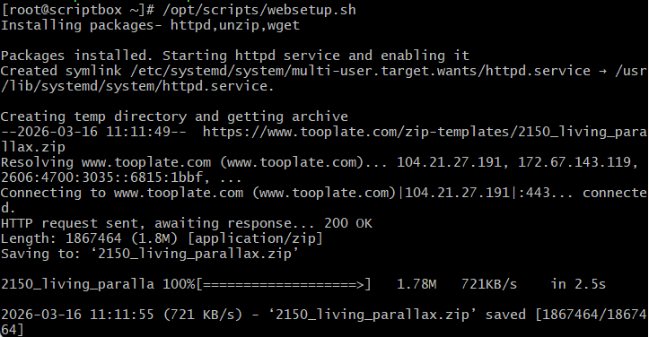
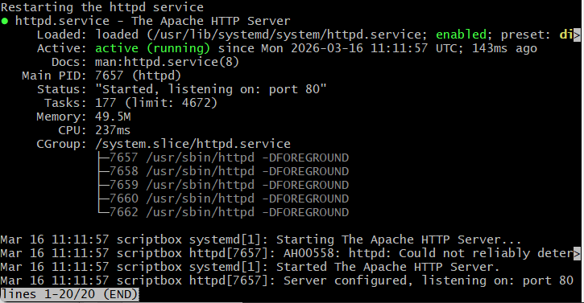

Bash Script to view available RAM, load average and free root partition size
#!/bin/bash
echo "Welcome $USER ON $HOSTNAME"
echo "--------------------------"
FREERAM=$(free -m | grep Mem | awk ' {print $4}')
LOAD=`uptime | awk ' {print $9}'`
ROOTFREE=$(df -h | grep '/dev/sda1' | awk ' {print $4}')
echo '---------------------------'
echo "Available free RAM is $FREERAM MB"
echo '----------------------------'
echo "Current Load Average $LOAD"
echo '----------------------------'
echo "Free ROOT partition size is $ROOTFREE"

Output
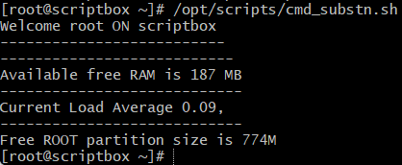
Bash script with ‘if’ statement execution
#!/bin/bash
read -p "Enter a number: " NUM
echo
if [ $NUM -gt 100 ]
then
echo "$NUM is greater than 100"
fi

echo "Script execution completed successfully."
Output
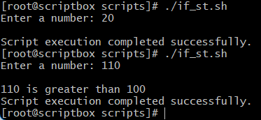
Bash script demonstrating ‘elif’ statement
#!/bin/bash
value=$(ip addr show | grep -v LOOPBACK | grep -ic mtu)
if [ $value -eq 1 ]
then
echo "1 Active Network Interface found"
elif [ $value -gt 1 ]
then
echo "Found multiple active interface"
else
echo "No active interface found"
fi
Output
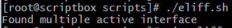

Bash script to check pid and start httpd process
#!/bin/bash
date
ls /var/run/httpd/httpd.pid > /dev/null
if [ $? -eq 0 ]
then
echo "Httpd process is running"
else
echo "Httpd process is not running"
systemctl start httpd
if [ $? -eq 0 ]
then
echo "Process started successfully"
else
echo "Unable to start the process"
fi
fi
echo "--------------------"
Output
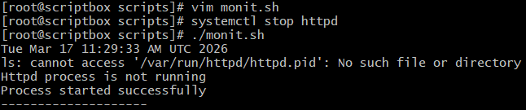
You can create a cronjob to run this script
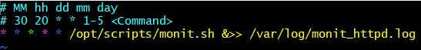
Every minute, hour, date, month and day. And the result will be stored in monit_httpd.log
Bash Script demo ‘For’ and ‘While’ loop statements
#!/bin/bash

for var1 in java python ruby bash
do
echo "Value is $var1"
done

counter=0
while [ $counter -lt 5 ]
do
echo "$counter"
counter=$(($counter+1))
done
Output
